**Pylot Belt Exam - Wish List**

Create an application that allows the logged user to add items on his wishlist and add other wishlist items to his own list. Other users can do the same things.

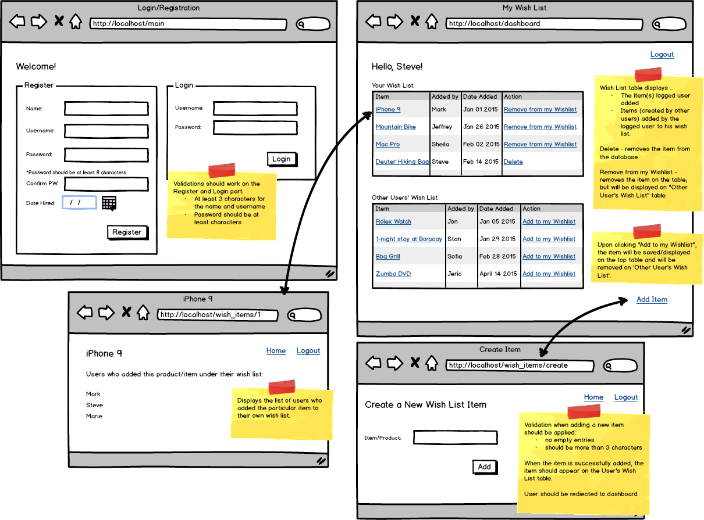

**Features required:**

1. Login and Registration with validations. Validation errors should appear on the page. Logout as well.
2. Display the logged user's wish list (top table) which includes the items logged user created and items logged user tagged to add on his own wishlist.
3. Ability to move items from "Other Users' Wish List" to the logged user's wish list table.
4. Ability to add new items. Validation applies.
5. Individual item page which displays the list of users who added the item to their own wishlist.
6. Removal of the items from wishlist table.
7. The person who added the product has an option to delete the product.
8. You must be able to deploy your work to Amazon EC2 and provide the IP address or subdomain/domain name to where your work has been deployed. Please note that Heroku deployment is not honored.

**Submission Requirement:** Your code, exported database file, a text file with the IP address or subdomain/domain name for the deployed work and short video demo link.

**Notes:**

* The wireframe is available for download [here](http://s3.amazonaws.com/General_V88/boomyeah/company_209/chapter_2996/handouts/chapter2996_5533_option-e-wishlist.png).
* Create a 2-3 video showing what you have built. On the video, show the functionality of the page you have built at localhost (not what was deployed). You may download a trial version of Jing, Snag-it or QuickTime for video creation. You may save it in Dropbox public folder and copy the public link.
* To prevent other students from copying your work, please make sure your video demo is set to unlisted or with a password, and code is not saved on GitHub.
* To minimize score deduction, please make sure you upload the complete requirements (database file, video demo).
* If you are having trouble uploading files on the Exam App, please DO NOT unlock another exam. Please email the file to remote-instructors@codingdojo.com and CC your instructor.